REPORT ON – National Conference – Built Environment and Beyond: Theory and Practice
Date: 18th October and 19th October 2022 in online mode

Sr. No. | Reporting items | Details
1 | Name of the Activity | National Conference – Built Environment and Beyond
2 | Name of the College | Dr. Bhanuben Nanavati College of Architecture, Maharshi Karve Stree Skikshan Samstha (MKSSS)
3 | District and State | Pune, Maharashtra
4 | No. of students participated in the Activity | Please find attached list
5 | No. of Resource persons | Dr. Joy Sen  Department of Architecture and Regional Planning, Indian Institute of Technology, Kharagpur  Ar. Habeeb Khan  President, Council of Architecture
6 | No. of Abstracts received | 64 (List attached)
7 | No. of Papers presented | 34 (List attached)
8 | No. of Faculty presenting paper | 34
9 | No. of Faculty Members Attending Conference | 104 (List attached)
 | No. of students participated | 302 (List attached)
7 | Name of the Head of the Institution | Dr.Anurag Kashyap
8 | Date | 18th October and 19th October 2022
9 | About National Conference | The intent of the National Conference ‘Built Environment and Beyond: Theory and Practice’ conducted on 18th and 19th October 2022 was to create an opportunity for the young and budding researchers (students of graduate and post graduate programs, faculty and professionals) in architecture and allied disciplines to write and present their research papers. The mode of conduct was envisaged online for a possibility of better participation from diverse participants. The theme was categorized into Four Tracks (Education, Practice, Planning, and Design & Theory) further into several Domains (Art and Architecture, Humanities, Culture and Heritage Conservation, Environment, Landscape, and Technology and Services) so that research topics would cover broader aspects.  A formal process of abstract submission was followed by paper submission which was further reviewed by experts. Further revised papers incorporating session panelists’ comments were invited. A plagiarism limit of 15% was allowed for publication. Only papers that have complied with the prescribed conditions have featured in this Peer Reviewed Conference Proceedings.  Online submission portal designed by Institute (BLMS) was used for submission and all formal communication.
 | Feedback/ Event Outcome | The event was well received by the authors, session panellists and the reviewers.  The outcome of the Conference was published with an ISBN as an online Conference Proceedings.  BNCA Publishing Cell | eBook ISBN: 978-81-955887-1-8

Photographs of the Event with titles –

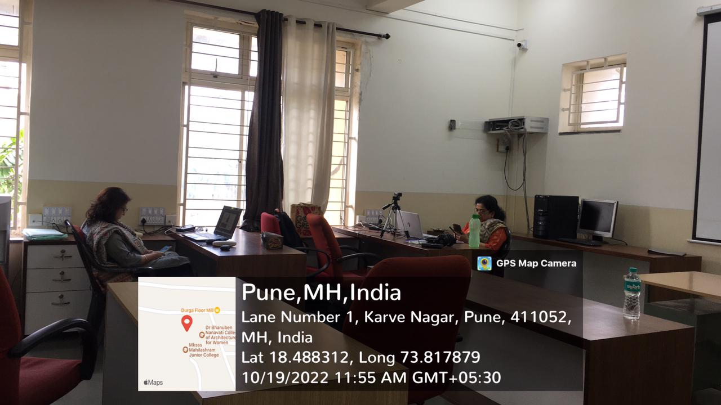
Conference virtual platform Set up in 108
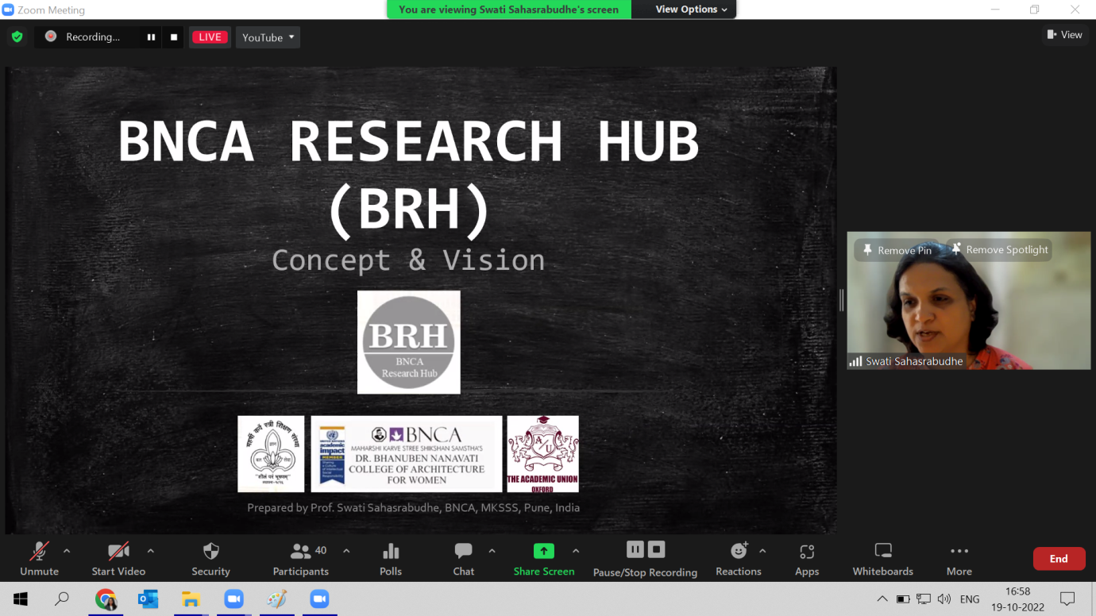
Dr. Swati Sahasrabudhe (BRH Head) briefing about BRH activities
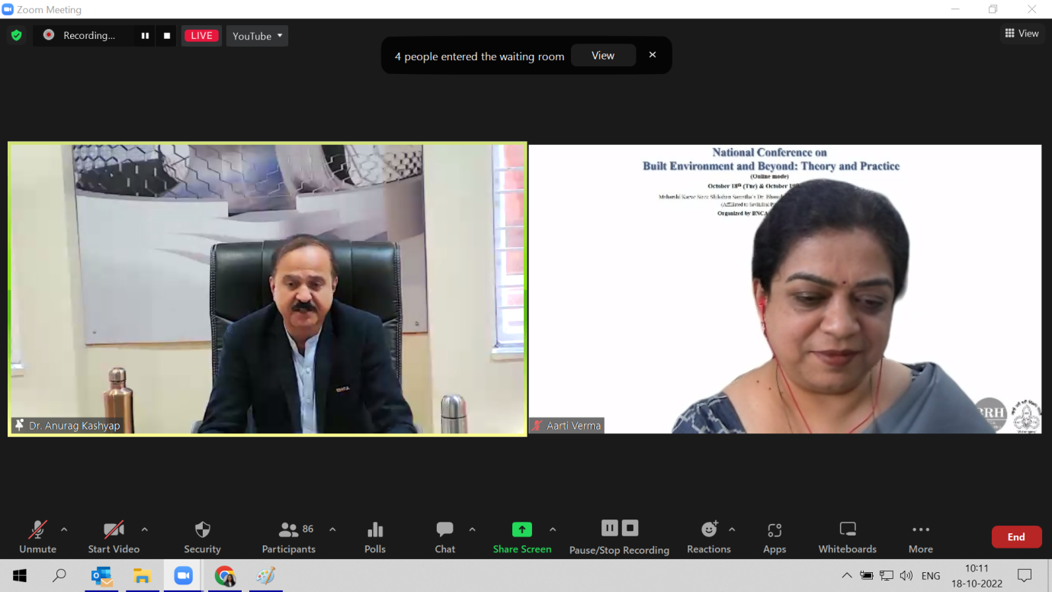
Principal Prof. Dr. Anurag Kashyap welcoming the audience

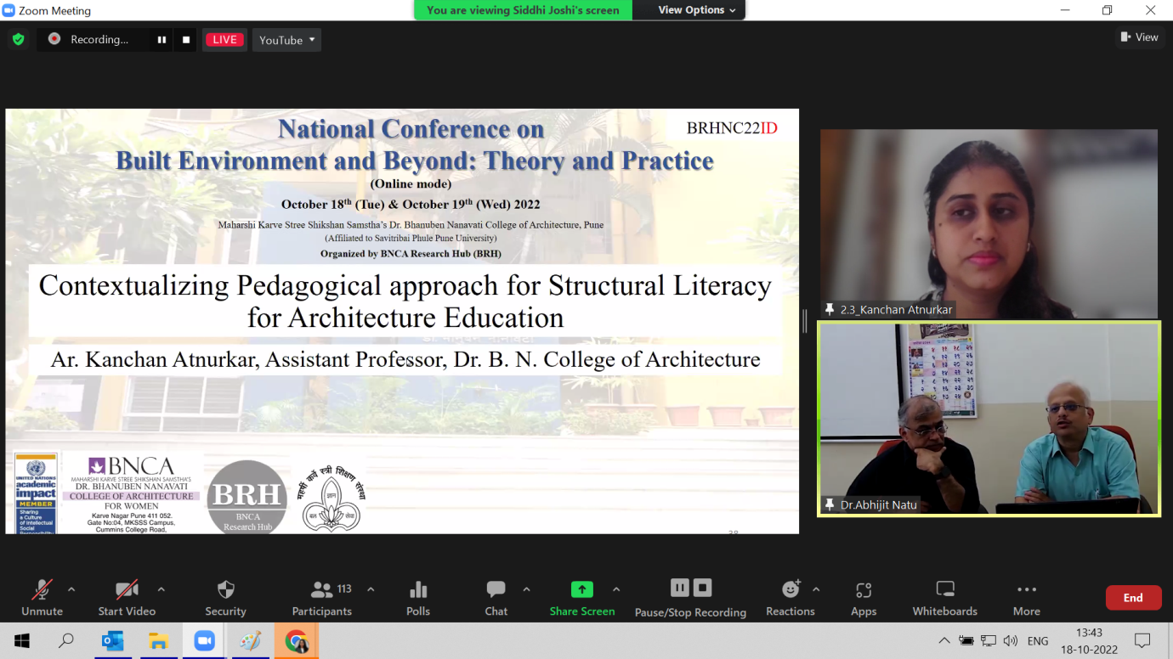
Prof. Kanchan Atnurkar presenting her paper
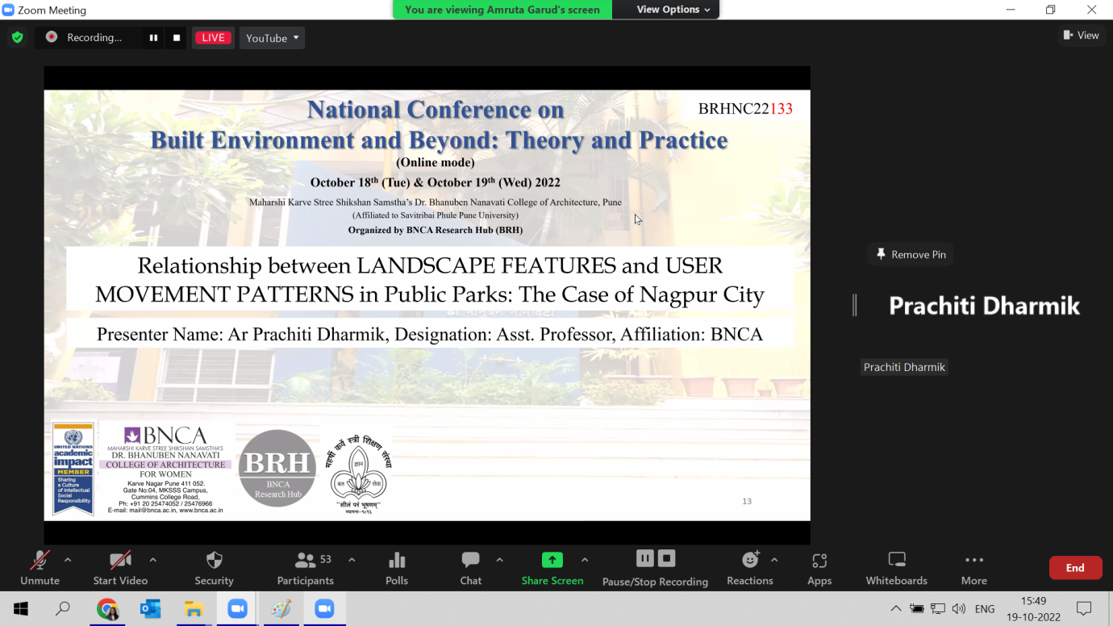
Prof. Prachiti Dharmik presenting her paper

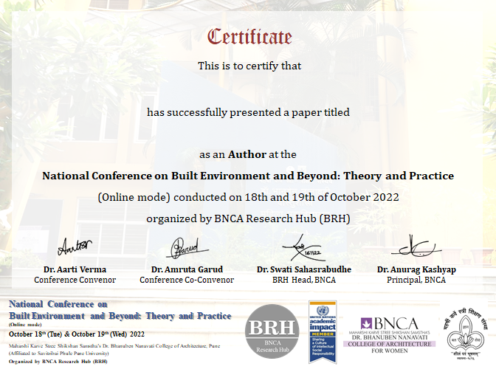
Certificates awarded to authors
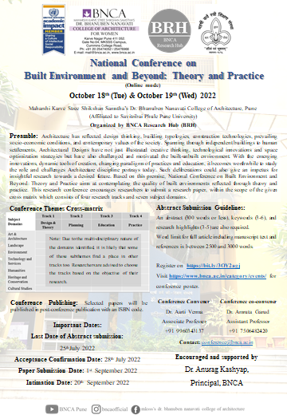 | 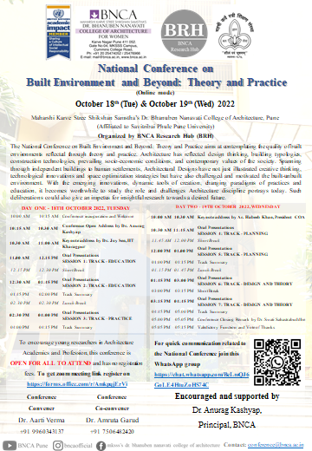

Posters circulated for Call for Abstracts and Paper Submission

Typical page of the Conference Proceedings

