C I S A A
ACITIVITIES UNDER CENTER FOR INTERDISCIPLINARY STUDIES IN ART AND ARCHITECTURE,BNCA,MKSSS, PUNE.

Activity 1: A QIP State level seminar on Symbiotic Relationship between Art and Architecture conducted on 19th and 20th Dec 2019.
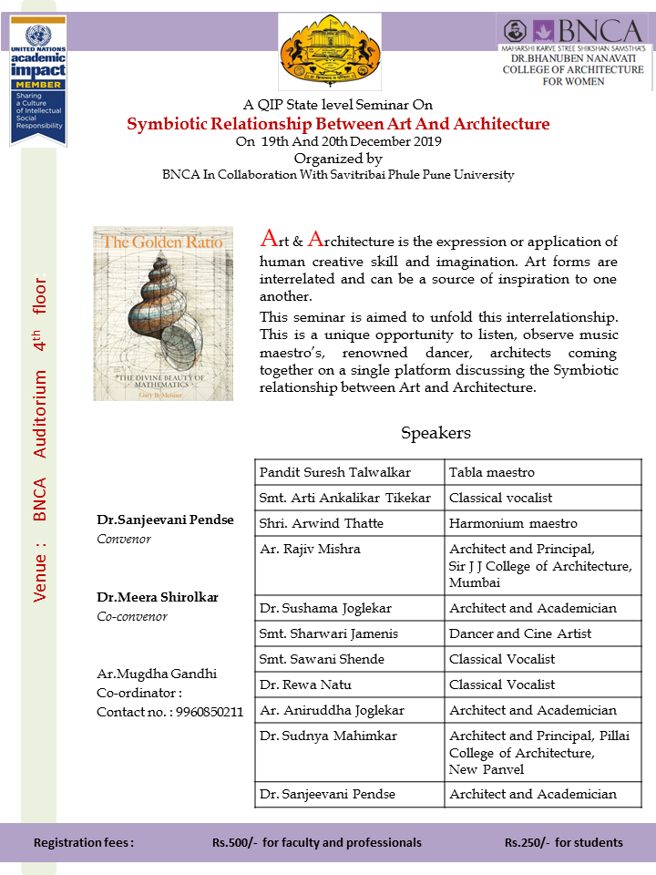

Activity 2: Academic Calendar prepared based on the designs done by the students .
Date: 27.6.22
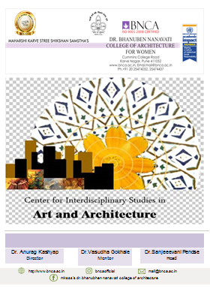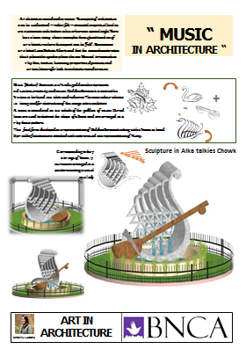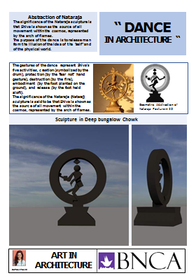

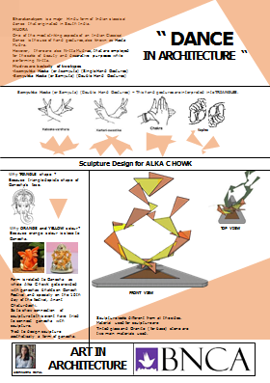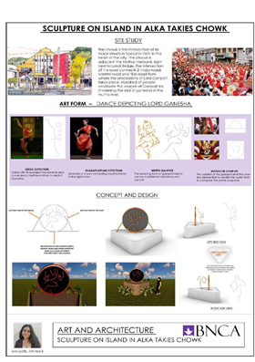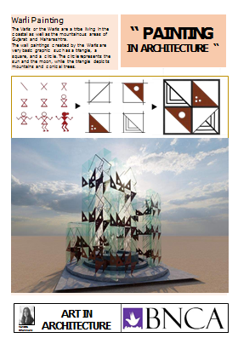

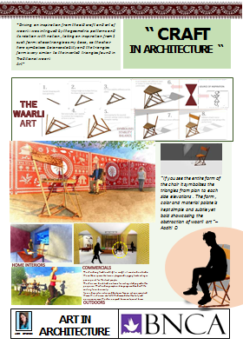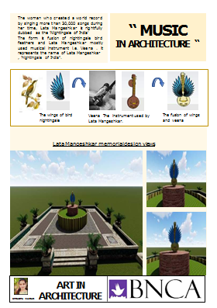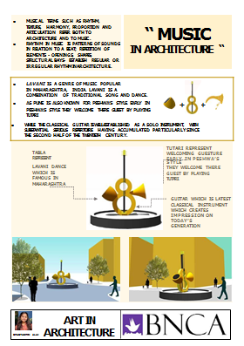

Activity 3: CISAA Day celebration
Date: 19.12.2021
Audio presentation on Music and Architecture

Activity 4: World Music Day Celebration
Date: 21.06.2021
Classical Vocal recital by Dr.Sanjeevani Pendse presented Raga Jaunpuri.

Activity 5: World Music Day Celebration
Date: 21.06.2022
Classical Vocal recital by Dr.Sanjeevani Pendse presented Katav a form of music.

Activity 6: WORKSHOP ON AUDITORY ART [4th and 6th October 2022 for BNCA AAD Students]
Lectures delivered:

- Introduction to Music and Architecture and the concept of Artes Liberales.

- Introduction to and definitions of common parameters in Music and Architecture.

- Understanding and application of the common parameter: Proportion.

- Examples of designs based on the relationship of Music and Architecture.

- Audio Questionnaire – Questions based on region, mood and parameters.

- Video on Coca cola beat box pavilion – Application of concepts of music and architecture.

Assignments:
- Photographic representation of the common parameters in Excel.

- Gist of all the lectures.

- Group work – [5 students] find out the basic information like its qualities, characteristics of different forms of Music.

- Download a melody of 2min of their choice.

- Group work: Analyze any one melody based on the following pointers:
Pattern, Time period, Intensity, Pauses, Color, Texture, IN between spaces, Mood, Frequency and identify the element and principle of design to be used to represent the analysis.

- Final design: Representation of the pattern based on the melody [ description of the melody, the identified elements and principles of design ]

ANNOUNCEMENT

Short term course on Music and Architecture – 10 hours commenced from 1st Jan 2024.

